**BSL Primary Curriculum**

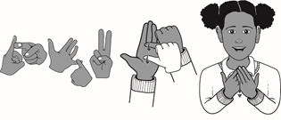

**Key Stage Two Programme of Study**

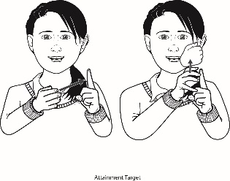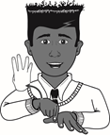

|  |  |
| --- | --- |
| **Year 4** | **Learning Outcomes** |
| **Using Language: Productive Skills**  Pupils should be able to produce: | |
| **Structure**   * topic-comment structured signing sentences. * signed sentence which includes a question. * correct signs for: who, what, where, when, why, which and how in sentences. * a story from a four picture-sequence story. * a narrative including appropriate pauses and pace by composing, rehearsing and adapting. * BSL connectives in sentences e.g. WHY, ASWELL. * role-shifting skills between two different subjects. * a short presentation of a topic or chosen subject area in a group or to the whole class. * a short poem of a topic or chosen subject area in a group or to the whole class. | |
| **Vocabulary**   * signs for time including passages of time e.g. 3-O’CLOCK, 25-PAST-3, 3-YEARS-TIME. * signs for money e.g. PENCE, POUND. * consistently signed pronouns e.g. YOU, ME, US, BOTH. * consistently 3 sign-sentences. * vocabulary from the four different BSL curriculum themes. * plausible guesses for signs that are unknown. * signs for shades of colour e.g. LIGHT / DARK. | |
| **Lip-Patterns**   * correct lip-patterns for signed homophones and near homophones. * BSL lip-patterns for manner and aspect signs e.g. CHEW, BRUSH. * some general BSL specific lip patterns e.g. VEE. | |
| **Description/NMF**   * descriptive signs including manner and aspect e.g. CAR-DRIVE-FAST / CAR-DRIVE-SLOWLY. * speed to show emphasis. * NMF consistently for at least ten different adjectives. * NMF for inflected verbs (modified base signs) e.g. WAIT / WAITING / WAIT-A-LONG-TIME. * NMF to show time e.g. YEARS-AGO, JUST-NOW. * facial expressions in a signed narrative using correct emphasis e.g. PLUMP-PERSON / TALL PERSON. | |
| **Handshapes**   * correct handshapes for classifiers: whole entity; handling and size and shape. * signs in context. * an increasing range of signs with numbers e.g. time, age, money and ordinal numbers. * signs using enumerators. * signed plurals using classifiers e.g. BOOKS / BOOK-PILE. | |
| **Fingerspelling**   * the alphabet fluently using their dominant hand and using correct handshapes and movements. * fingerspelling for names as it first appears in a story and then use initials or sign names thereafter. | |
| **Understanding Language: Receptive Skills**  Pupils should understand: | |
| **Structure**   * and answer questions for fiction and non-fiction events. * the shift between roles e.g. role-shifting between adult and child. * and ask for clarification. * questions and answer in BSL using cohesive sentences. | |
| **Vocabulary**   * the signed differences between: money, age and time using location and placement. * timelines in a school setting e.g. school timetable/routine. * new vocabulary for different topics. * and be able to repeat back sentences. * the difference between colour and skin colour signs. | |
| **Lip-Reading**   * by lip-reading blended fingerspelling. * by lip-reading fingerspelled names. * by lip-reading homophones and near homophones in context. | |
| **Description/NMF**   * what manner and emotions are being conveyed in a story or event. * inflected verbs in a sentence. * negation NMF in sentences e.g. EMPTY / NOTHING / RUN-OUT. | |
| **Directionality**   * the role of directional verbs and why e.g. HELP-YOU / HELP-ME * when directional verbs are used and for which subject. * when time is used e.g. 2-DAYS-AGO, 3-DAYS-LATER. * and correctly use eye gaze. * how placement is used to describe the scene. | |
| **Comprehension**   * and discuss their understanding of events and stories. * views and opinions of others. * signed stories/events and answer questions. * fiction and non-fiction video clips. * and be able to summarise and feedback points. | |
| Pupils should be taught to: | |
| * sign their thoughts aloud. * share ideas and opinions in BSL. * use prior knowledge and new vocabulary learnt. * develop their knowledge of stories and non-fiction texts and be exposed to a wider range of vocabulary. * have their understanding of BSL structure established. * sign frequently around the school for information and enjoyment. * develop a positive attitude to learning BSL by meeting and conversing with Deaf people. * watch Deaf programmes or BSL clips e.g. BSL Zone, See Hear. | |