**BSL Primary Curriculum**

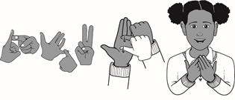

**Key Stage Two Programme of Study**

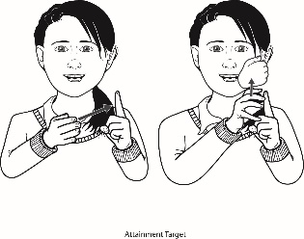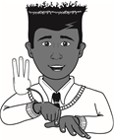

|  |  |
| --- | --- |
| **Year 3** | **Learning Outcomes** |
| **Using Language: Productive Skills**  Pupils should be able to produce: | |
| **Structure**   * a timeline of events using BSL tenses e.g. WILL or BEEN. * sentences retelling an event about a daily routine activity. * signed pronouns e.g. YOURS, MINE, YOU, ME. * a story from a three picture-sequence story. * a short presentation in a group or to the whole class. * pauses in retelling an event or story. * BSL connectives in sentences e.g. IF, WHY, BUT. | |
| **Vocabulary**   * signs for time e.g. NEXT WEEK, 3 YEARS LATER, LAST YEAR, QUARTER TO/PAST * signed pronouns e.g. YOU, ME, US, BOTH. * simple vocabulary to make at least 3 sign-sentences. * vocabulary from the four different curriculum themes. | |
| **Lip-Patterns**   * correct lip-patterns for signed homophones and near homophones. * BSL lip-patterns for manner and aspect signs e.g. LONG-TIME, EATING. * some general BSL lip patterns. | |
| **Description/NMF**   * emphasis with use of manner, e.g. LIGHT RAIN/HEAVY RAIN. * NMF in signs for possession e.g. YOURS, MINE. * NMF in ten different adjectives. * NMF for inflected verbs e.g. WALK, WALKED QUICKLY, WALKED SLOWLY. * NMF to show time e.g. LONG-TIME-AGO, RECENT. | |
| **Handshapes**   * signs in context. * an increasing range of signs with numbers e.g. time, age, money and ordinal numbers. * signed plurals e.g. LOTS-OF, MANY. * signs using their dominant hand consistently. | |
| **Spelling**   * addresses e.g. name of places. * Letters of the alphabet. * fingerspelling for names as it first appears in a story and then use initials or sign names thereafter. | |
| **Understanding Language: Receptive Skills**  Pupils should understand: | |
| **Structure**   * and ask for clarification. * simple questions and answer using BSL sentence order. * appropriate intonations using facial expressions. * and respond appropriately to retell a sequence of events and give information. * fingerspelling at speed. * past, present and future tenses and recognise when these are being used. * brief explanation of events quickly. * and be familiar with everyday greetings. * and be familiar with signs in functional settings. * and recognise recurring signs. * a signed poem. | |
| **Vocabulary**   * 70-75 new vocabulary signs. * simple words with pictures and match signs to these. * and be able to sign BSL sentences to match pictures. * and be able to repeat back sentences. * and recognise the signs for tense e.g. BEEN and WILL. * and know common signs. * and be exposed to a wider range of vocabulary. | |
| **Lip-Reading**   * by lip-reading blended fingerspelling. * by lip-reading fingerspelled names. * by lip-reading homophones and near homophones (within topic). | |
| **Description/NMF**   * what emotions and manner are being conveyed in a story or event. * which NMF is used to describe types of weather. * question forms from the use of NMF e.g. eyebrow movement. | |
| **Directionality**   * when directional verbs are used and for which subject. * when time is used e.g. 2-DAYS-AGO, 3-DAYS-LATER. * and use eye gaze correctly. * when pointing is used to refer to something. * how placement is used to describe the scene. | |
| **Comprehension**   * and identify emotions from facial expressions, aspect and manner. * and answer questions in BSL order. * and be able to discuss the context of conversations and meaning of some signs. * head movements e.g. YES and NO. * short signed stories, answer story questions and share views/opinions. | |
| Pupils should be taught to: | |
| * sign their thoughts aloud. * share ideas and opinions in BSL. * use prior knowledge and new vocabulary learnt. * have their understanding of BSL structure established. * develop their knowledge of stories and non-fiction texts and be exposed to a wider range of vocabulary. * develop a positive attitude to learning BSL by meeting and conversing with Deaf people. * watch Deaf programmes or BSL clips e.g. BSL Zone, See Hear. | |