**BSL Primary Curriculum**

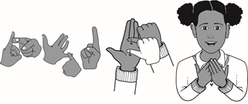

**Key Stage One Programme of Study**

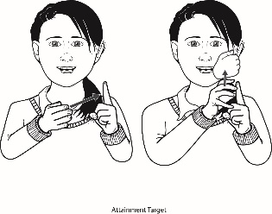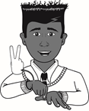

|  |  |
| --- | --- |
| **Year Two** | **Learning Outcomes** |
| **Using Language: Productive Skills**  Pupils should be able to produce: | |
| **Structure**   * a fully signed sentence with an adjective. * a signed subordination sentence e.g. WHY (because/giving reason). * a fully connective sentence e.g. OR. * and make simple additions, revision and corrections to their own signing. * a narrative about personal experiences and those of others. * a description about a real event. * a poem. * and plan how they are going to sign. * and retell simple sentences. * question sentences. * information and instructional sentences. | |
| **Vocabulary**   * 50-60 key vocabulary from the 4 BSL Curriculum themes. * signs using BSL timeline e.g. TOMORROW, NOW, TODAY, YESTERDAY, BEFORE. * past, present and future tenses correctly e.g. BEEN and WILL. * signing prepositions e.g. BELOW, ABOVE, BETWEEN, AROUND, THROUGH. * favourite signs. * signs for time: HALF-PAST. | |
| **Lip-Patterns**   * signs and lip-patterns correctly for homophones and near homophones. * correct lip-patterns for numbers. * correct lip-patterns for colours. * correct lip-patterns for days of the week and months of the year. | |
| **Description/NMF**   * more signed emotions e.g. EMBARRASSED, EMOTIONAL, SHY, STUBBORN. * adjectives and adverbs in sentences. * expanded noun phrases to describe. * pauses to break and end sentences. * aspect to signing sentences. * inflections to verbs (modified base signs) e.g. RUN/RUN SLOWLY/RUN FAST. | |
| **Handshapes**   * correct possessive signs. * numbers up to 100. * calendar dates and year/s. * numbers for age in the correct location. * correct handshapes, NMF, movement, location and orientation for most signs. | |
| **Spelling**   * family and friends’ names fingerspelled. * the alphabet in order fingerspelled. * clearly fingerspelled letters especially two same letters e.g. SPELL. * fingerspelling with increasing fluency. | |
| **Understanding Language: Receptive Skills**  Pupils should understand: | |
| **Structure**   * appropriate intonations using facial expressions. * and respond appropriately to retell a sequence of events and give information. * fingerspelling at speed. * past, present and future tenses and recognise when these are being used. * brief explanation of events quickly. * and become familiar with everyday greetings. * and become familiar with signs in functional settings. * and recognise recurring signs. * a signed poem. | |
| **Vocabulary**   * 50-60 key vocabulary from the 4 BSL Curriculum themes. * and recognise the signs for tense e.g. BEEN and WILL. * and know common signs. * simple words with pictures and match signs to these. * signed descriptions and find images to match. * and repeat back sentences. * and be exposed to a wider range of vocabulary. | |
| **Lip-Reading**   * and correctly lip-read blended fingerspelling. * and correctly lip-read fingerspelled names. * and correctly lip-read homophones and near homophones. * that some meanings of signs are defined by the lip patterns used. | |
| **Description/NMF**   * and interrupt in order to clarify meaning. * more signed emotions e.g. EMBARRASSED, EMOTIONAL, SHY, STUBBORN. * adjectives and adverbs in sentences. * expanded noun phrases to describe. * pauses to break and end sentences. * aspect to signing sentences. * inflections to verbs (modified base signs) e.g. RUN/RUN SLOWLY/RUN FAST. | |
| **Directionality**   * the direction of verbs being signed e.g. I-GIVE-YOU / YOU-GIVE-ME. * signs for time: NEXT WEEK, LAST WEEK, YESTERDAY, TODAY, TOMORROW. * the use of placement and referents. * eye gaze. | |
| **Comprehension**   * and answer questions. * and predict what might happen next in stories and events. * and participate in discussions about events, books, poems, etc. * discuss and explain their comprehension of books, poems, etc. * the importance of using correct handshapes. * and know one handshape can be used for a variety of signs. * discuss, watch and express views. | |
| Pupils should be taught to: | |
| * sign their thoughts aloud. * share ideas and opinions in BSL. * use prior knowledge and new vocabulary learnt. * have their understanding of BSL structure established. * develop their knowledge of stories and non-fiction texts and be exposed to a wider range of vocabulary. * reinforce their deaf awareness knowledge: * how to get attention * eye contact * using gestures/paper and pen if they do not know the sign * keeping the mouth clear * not shouting. | |