**BSL Primary Curriculum**

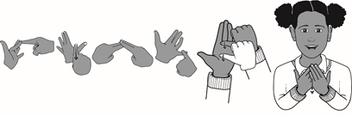

**Early Years Foundation Stage Programme of Study**

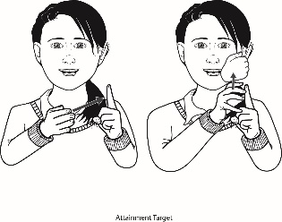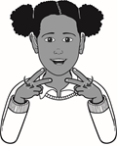

|  |  |
| --- | --- |
| **Nursery** | **Learning Outcomes** |
| **Receptive and Productive Skills**  Pupils should be able to understand and produce signs for: | |
| * 10 basic colours (red, blue, yellow, green, pink, purple, orange, brown, white, black). * numbers up to 10. * their age e.g. 3-YEARS-OLD. * 2-word sentences E.g. WANT MILK. * at least 2 wh-questions: who, where or which. * 10 basic verbs per term. * 10-15 key words in class-based topics per term. * 4 key emotions: happy, sad, angry, excited and use correct facial expressions. * simple greetings e.g. hello, goodbye, please, thank you. * basic deaf awareness e.g. tapping on shoulder, no shouting, eye contact etc. * stories: to watch BSL stories and sign along repetitive phrases. * simple nursery rhymes and songs. * basic narratives: nouns, commonly used verbs and adjectives. * their sign name and first initial/letter of their name. * negation signs and head movements e.g. no, not allowed. | |

|  |  |
| --- | --- |
|  | |
| **Reception** | **Learning Outcomes** |
| **Productive Skills**  Pupils should be able to produce signs for: | |
| * numbers up to 20. * additional colours: grey, gold, silver, bronze. * wh-questions: who, what, where, when and why. * 20-25 key vocabulary from class-based topic per term. * 4 additional emotions: frightened, shocked, upset, and scared with correct use of facial expressions. * time e.g. wait, soon, later, tomorrow. * a string of 3 signs in a sentence e.g. ME GO PARK / PARK ME GO. * everyday routine e.g. ME WAKE UP / ME EAT BREAKFAST / ME CLEAN TEETH / ME OUTSIDE PLAY. * simple adjectives e.g. big, small. * simple sentences of minimum 3 signs based on what is seen first e.g. ROOM ME IN / CAR DRIVE FAST. * their sign names and fingerspell their names. * basic deaf awareness e.g. tapping on shoulder, eye contact etc. | |
| **Receptive Skills**  Pupils should understand signs for: | |
| * pronouns with placements and referents. * numbers up to 20. * a range of colours: grey, gold, silver, bronze. * wh-questions: who, what, where, when and why. * 20-25 key vocabulary from class-based topics per term. * 4 additional emotions: frightened, shocked, upset, scared. * time: wait, soon, later, tomorrow. * plurals in BSL by the following steps: a) numbers, b) lots of, c) repetition. * negation in sentences by NMF and correct verb use of negation e.g. no, don’t like. * adjectives describing things. (Size/tracing, entity/objects and handling classifiers.) * verbs for everyday life and understand the direction of signs e.g. YOU-HELP-ME / ME-HELP-YOU. * key vocabulary in stories and retell the story chronologically. * basic deaf awareness e.g. tapping on shoulder, eye contact etc. | |
| Pupils should be taught to: | |
| * watch and sign stories, understand and retell stories chronologically. * be aware that BSL has its own structure. * know that BSL uses connectives through pauses, silence or head nods. * know how to get attention, maintain eye contact, use gestures, keeping mouth clear, waving, not shouting. | |